**Introduction to Cisco Packet Tracer**

**LAB # 09**



**Spring 2025**

Submitted by: **Mohsin Sajjad**

Registration No: **22pwsce2149**

Class Section: **A**

“On my honor, as student of University of Engineering and Technology, I have neither given nor received unauthorized assistance on this academic work.”



Student Signature: ______________

Submitted to:

**Dr. Yasir Saleem Afridi**

Month Day, Year (06 05, 2025)

Department of Computer Systems Engineering

University of Engineering and Technology, Peshawar

**CSE 303L: Data Communication and Computer Networks**

|  |  |  |  |  |
| --- | --- | --- | --- | --- |
| **Demonstration of Concepts** | **Poor (Does not meet expectation (1))**  The student failed to demonstrate a clear understanding of the assignment concepts | **Fair (Meet Expectation (2-3))**  The student demonstrated a clear understanding of some of the assignment concepts | **Good (Exceeds Expectation (4-5)**  The student demonstrated a clear understanding of the assignment concepts | **Score**  **30%** |
| **Accuracy** | The student mis-configured enough network settings that the lab computer couldn't function properly on the network | The student configured enough network settings that the lab computer partially functioned on the network | The student configured the network settings that the lab computer fully functioned on the network | **30%** |
| **Following Directions** | The student clearly failed to follow the verbal and written instructions to successfully complete the lab | The student failed to follow the some of the verbal and written instructions to successfully complete all requirements of the lab | The student followed the verbal and written instructions to successfully complete requirements of the lab | **20%** |
| **Time Utilization** | The student failed to complete even part of the lab in the allotted amount of time | The student failed to complete the entire lab in the allotted amount of time | The student completed the lab in its entirety in the al | **20%** |

**Credit Hours: 1**

# CSE 303L: Data Communication and Computer Networks

**Credit Hours: 1**

|  |  |  |  |  |  |
| --- | --- | --- | --- | --- | --- |
| **Demonstration of**  **Concepts** | **Poor (Does not meet**  **expectation (1))**    The student failed to demonstrate a clear understanding of the  assignment concepts | **Fair (Meet Expectation**  **(2-3))**    The student demonstrated a clear understanding of some of the assignment concepts | **Good (Exceeds**  **Expectation (4-5)**    The student demonstrated a clear understanding of the assignment concepts | **Score**      **30%** |  |
| **Accuracy** | The student mis-configured enough network settings that the lab computer couldn't function properly on the network | The student configured enough network settings that the lab computer partially functioned on the network | The student configured the network settings that the lab computer fully functioned on the network | **30%** |  |
| **Following Directions** | The student clearly failed to follow the verbal and written instructions to successfully complete the lab | The student failed to follow the some of the verbal and written instructions to successfully complete all requirements of the lab | The student followed the verbal and written instructions to successfully complete  requirements of the lab | **20%** |  |
| **Time Utilization** | The student failed to complete even part of the lab in the allotted amount of time | The student failed to complete the entire lab in the allotted amount of time | The student completed the lab in its entirety in the allotted amount of time |  | **20%** |

**Lab 9**

# Introduction to Cisco Packet Tracer

# OBJECTIVES OF THE LAB

## --------------------------------------------------------------------------------------------------------------

This lab aims to introduce Cisco Packet Tracer. Some specific topics covered in this lab are

* Downloading Packet Tracer from NetAcad
* Installing Packet Tracer
* Cisco Packet Tracer Overview
* Creating Devices
* Adding Modules
* Making Connections

**-------------------------------------------------------------------------------------------------------------**

## Introduction

Cisco Packet Tracer is an innovative network simulation and visualization tool. This free software helps you to practice your network configuration and troubleshooting skills via your desktop computer or an Android or iOS based mobile device. Packet Tracer is available for both the Linux and Windows desktop environments.

With Packet Tracer you can choose to build a network from scratch, use a pre-built sample network, or complete classroom lab assignments. Packet Tracer allows you to easily explore how data traverses your network. Packet Tracer provides an easy way to design and build networks of varying sizes without expensive lab equipment.

1. Downloading
2. Installing Cisco Packet Tracer
3. Cisco Packet Tracer overview

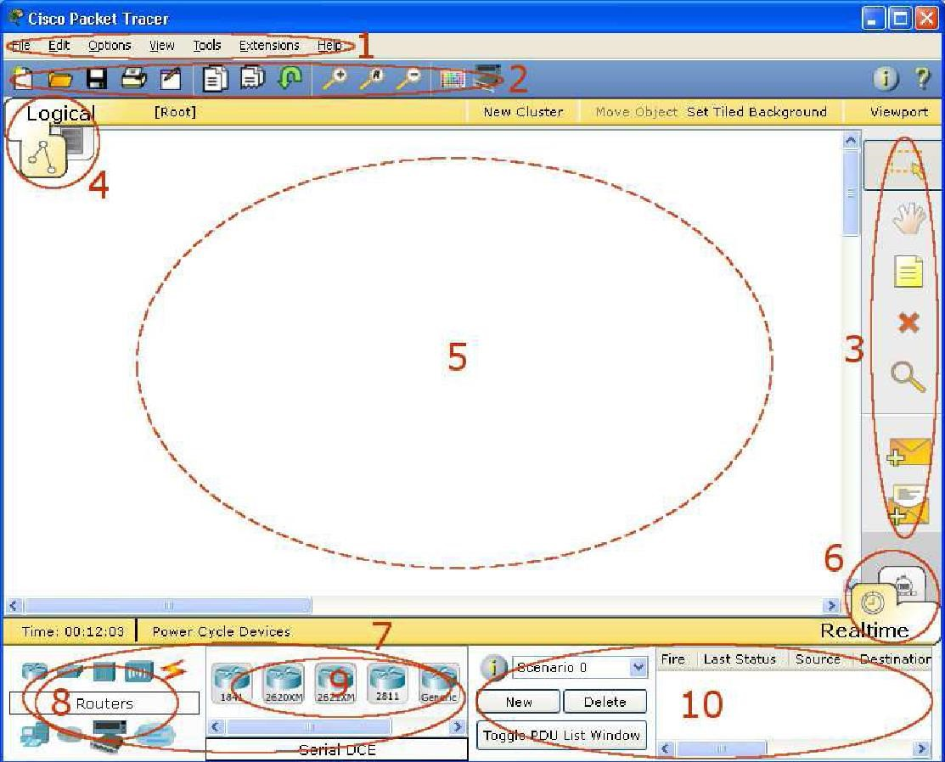

|  |  |  |
| --- | --- | --- |
| 1 | **Menu Bar** | This bar provides the File, Edit, Options, View, Tools, Extensions, and Help menus. You will find basic commands such as Open, Save, Print, and Preferences in these menus. You will also be able to access the Activity Wizard from the Extensions menu. |
| 2 | **Main Tool Bar** | This bar provides shortcut icons to the File and Edit menu commands. This bar also provides buttons for Zoom, the drawing Palette, and the Device Template Manager. On the right, you will also find the Network Information button, which you can use to enter a description for the current network (or any text you wish to include). |
| 3 | **Common Tools**  **Bar** | This bar provides access to these commonly used workspace tools: Select, Move Layout, Place Note, Delete, Inspect, Add Simple PDU, and Add Complex PDU. See "Workspace Basics" for more information. |
| 4 | **Logical/Physical**  **Workspace and**  **Navigation Bar** | You can toggle between the Physical Workspace and the  Logical Workspace with the tabs on this bar. In Logical  Workspace, this bar also allows you to navigate through levels of a cluster, create a new New Cluster, Move Object, Set Tiled Background, and Viewport. In Physical Workspace, this bar allows you to navigate through physical locations, create a New City, create a New Building, create a New Closet, Move Object, apply Grid to the background, Set Background, and go to the Working Closet. |
| 5 | **Workspace** | This area is where you will create your network, watch simulations, and view many kinds of information and statistics. |
| 6 | **Realtime/Simul ation Bar** | You can toggle between Realtime Mode and Simulation Mode with the tabs on this bar. This bar also provides buttons to Power Cycle Devices as well as the Play Control buttons and the Event List toggle button in Simulation Mode. Also, it contains a clock that displays the relative Time in Realtime Mode and Simulation Mode. |
| 7 | **Network**  **Component Box** | This box is where you choose devices and connections to put into the workspace. It contains the Device-Type Selection Box and the Device-Specific Selection Box. |
| 8 | **Device-Type Selection Box** | This box contains the type of devices and connections available in Packet Tracer 5.1. The Device-Specific Selection Box will change depending on which type of device you choose. |
| 9 | **Device-Specific Selection Box** | This box is where you choose specifically which devices you want to put in your network and which connections to make. |
| 1  0 | **User Created**  **Packet**  **Window\*** | This window manages the packets you put in the network during simulation scenarios. See the "Simulation Mode" section for more details. |

### 4. Creating Devices

1. Choose a device type from the **Device-Type Selection** box
2. Click on the desired device model from the **Device-Specific Selection** box
3. Click on a location in the workspace to put your device in that location
4. If you want to cancel your selection, press the **Cancel** icon for that device
5. Alternatively, you can click and drag a device from the **Device-Specific Selection** box onto the workspace
6. You can also click and drag a device directly from the **Device-Type Selection** box and a default device model will be chosen for you

### 5. Adding Modules

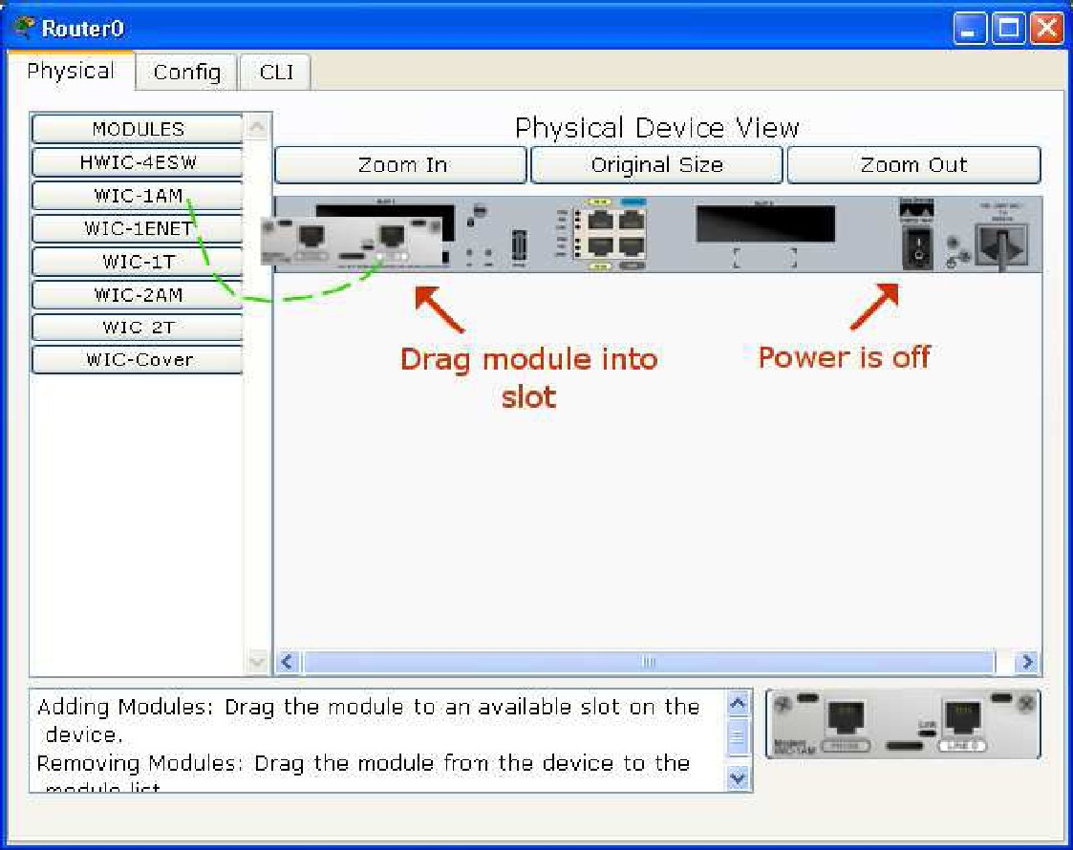

1. Click on a device to bring up its configuration window.
2. By default, you will be in the **Physical Device View** subpanel of the device.
3. You can browse (by clicking) through the list of modules and read their description in the information box at the bottom.
4. When you have found the module you want to add, simply drag it from the list into a compatible bay on the device picture.
5. You can remove a module by dragging it from the device back into the list.

#### 6. Making Connections

1. To make a connection between two devices, first click the **Connections** icon from the **Device-Type Selection** box to bring up the list of available connections.
2. Then click the appropriate cable type.
3. The mouse pointer will change into a "connection" cursor.
4. Click on the first device and choose an appropriate interface to which to connect.
5. Then click on the second device and do the same.
6. A connection cable will appear between the two devices, along with link lights showing the link status on each end (for interfaces that have link lights).

1. Mention the downloading and installation steps with screenshots.

Perform the following step to successfully install the Cisco packet tracer on PC.

* 1. Required email.
  2. After successful Login, click on Resources and then click on Download it.
  3. Now [Download Packet Tracer](https://www.netacad.com/courses/packet-tracer) for the Windows platform. You can download it for Linux as well as for Mac OS.
  4. After downloading, double-click on the packet tracer 8.2 icon and start the installation of it.
  5. Fill in the radio button “I Accept the agreement” and then click on Next.

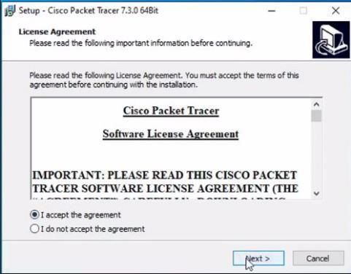

* 1. Here you can decide its installation location, if you don’t want to change it then just click on Next

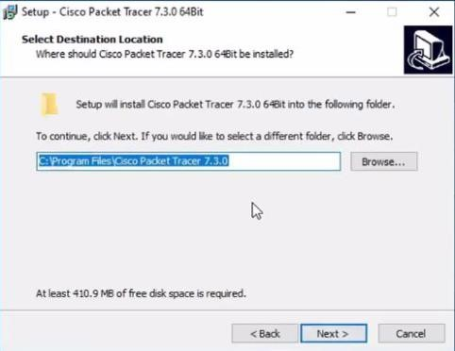

* 1. After completing all step click on finish .

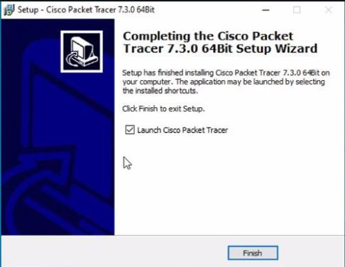

1. Make a simple connection between two end devices like PCs.

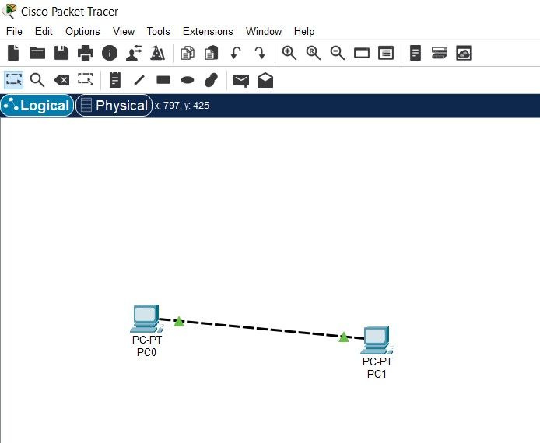

1. Check whether the two devices were able to communicate or not?

**Answer:** **No communication, for communication perform the following steps:**

To establish a simple connection between two PCs in Packet Tracer and verify their communication, first, physically connect the PCs using a copper straight-through cable. Then, assign IP addresses to each PC on the Desktop tab, IP configuration. Finally, use the command prompt on one PC to ping the IP address of the other PC, which will confirm or deny connectivity

1. Which ethernet cable did you use for the connection of two end devices?

**Answer:** Cross Ethernet cable is used for two same end devices.